DECIBELS 2025
DECIBELS 2025, The first and the premier event of the ECE Association, was conducted from 14th to 16th October 2025. The event was designed to refine students’ technical and non-technical capabilities, while providing valuable insights into the dynamics of placement preparation. The event was a grand fusion of creativity, intellect, fun where mins collaborate, ideas ignite and innovation takes center stage. Over the course of three days, participants were engaged in a variety of challenges encompassing aptitude-based activities, technical, non-technical.
- QUANTIFYX
- CHIP N CODE
- CIPHERHUNT

QUANTIFYX
The first event of DECIBELS’ 25 was QUANTIFYX, an aptitude challenge held on 14 October 2025. It was designed to collectively boost students’ aptitude-skills and serve as valuable preparation for their upcoming placement processes.
ROUND-1: PLOTRIXA
Two Participants are combined as a team, each team receiving two sets of questions—one set for each member. One member will answer questions that correspond to points along the x-axis, while the other tackles questions that correspond to the y‐axis. Once they have their answers, the team will plot all the points on a graph and then join them in sequence to complete the test. For instance, if the x‐axis question “2 + 3 =” yields an answer of 4, and the y‐axis question “What is the largest flightless bird?” yields an answer of 4 as well (Ostrich → 4), then the team marks the point (4, 4) on the graph. This event will shortlist 5 team in the junior category and 5 teams in the senior category for the next round
ROUND-2: ROLL N STROLL
Teams will compete on a large arithmetic-square grid spread on the floor. Each team logs into a virtual room using a code to access their buzzer system; one team member will answer aptitude questions and the other will physically move on the grid. An aptitude question will be projected onto the screen, and when a team solves the question they answer it as a rapid fire round. The first team to buzz gets the opportunity to answer the question—if correct, they roll a dice and move that many spaces on the grid. Each block in the grid may carry bonus points, negative points, or no points at all. The first team to traverse and complete the grid wins. The overall event is a mind-bender for the particpants.
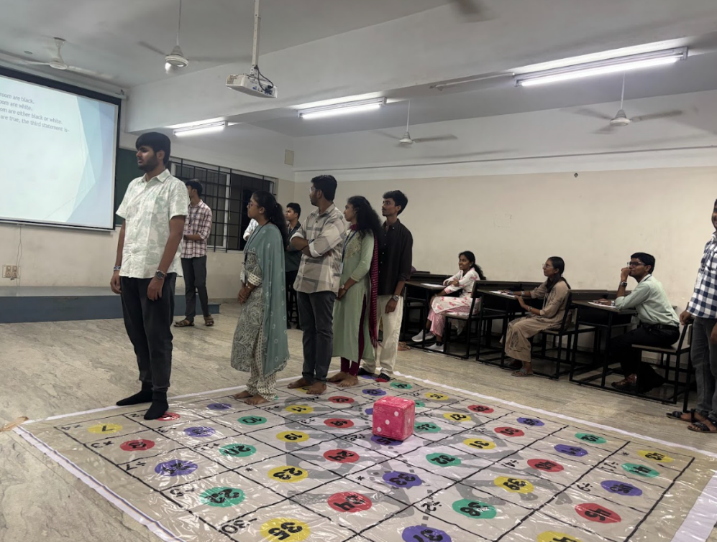
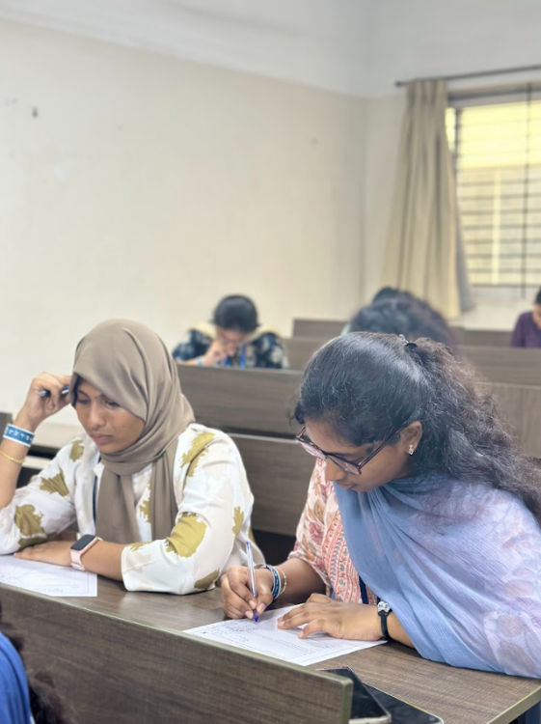
CHIP N CODE
The technical event CHIP N CODE was one of the most prominent highlights of DECIBELS 2025. It was meticulously designed to test students’ analytical thinking, teamwork, and problem-solving skills through creative and intellectually stimulating challenges. This year, CHIP N CODE comprised two engaging rounds that kept participants fully immersed from start to finish:
- COGNITECH
- SILIQUEST
ROUND-1: COGNITECH
In the first round, each team, comprising two participants, was provided with five technical questions—two of easy level and two of medium level and one of difficulty level—to be solved within 10 minutes. Teams that successfully completed the first four questions within the allotted time proceeded to the designated cabin to submit their answer sheets and performed tasks assigned by the in-charges. Entertaining as well as time consuming Tasks like sudoku, word and picture search etc. After completion of the given tasks, participants had to solve the last question-the hard and the creative one. Demonstrate analytical thinking, team work and problemsolving skills.
ROUND-2: SILIQUEST
In Round 2, the teams that advanced from Round 1 will tackle a more dynamic stage of the competition.
Round 2 for first years: Each team will be assigned a unique flow path so that no two teams cross paths while moving through the setup. Ten tables, each labeled with a letter, will be set up. At each table, a specific technical task or a brain tricking task will be placed. An in-charge person will be at each table to explain the task, monitor progress, and record the time the team takes. Teams must complete the task at a table before moving on to their next table in the sequence. The challenge is to solve each technical task with both speed and accuracy under time pressure and to tackle the time consuming brainstorming activity.The team that completes all tasks in the shortest cumulative time will be declared the winner of this round.
Round 2 for 2nd and 3rd years: In Round 2, the 3 teams that qualified will face a unique and engaging challenge. Firstly, each team carries equal credit points .Secondly, three circuit diagrams will be projected on the screen, and each team must carefully study and memorise them. Then each team will receive a breadboard with a partially completed circuit; their task is to identify the missing component. To obtain that component, they must go to the assigned coordinator, who will present a simple coding question to solve. If a team cannot recall the circuit diagram, they may approach a different coordinator, solve a new coding question, and then the diagram will be shown to them again for 2 minutes. For each wrong answer, points will be deducted. The team that completes the circuit successfully—both identifying the missing component(s) and solving the coding questions—with the best combination of speed and accuracy will win.
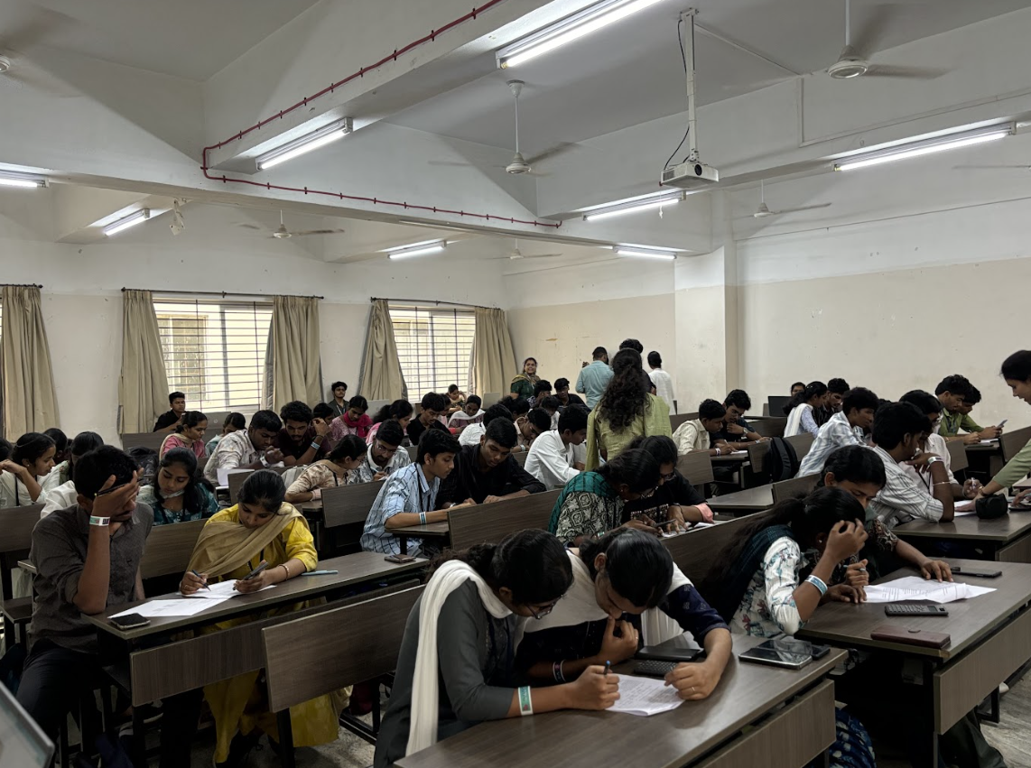
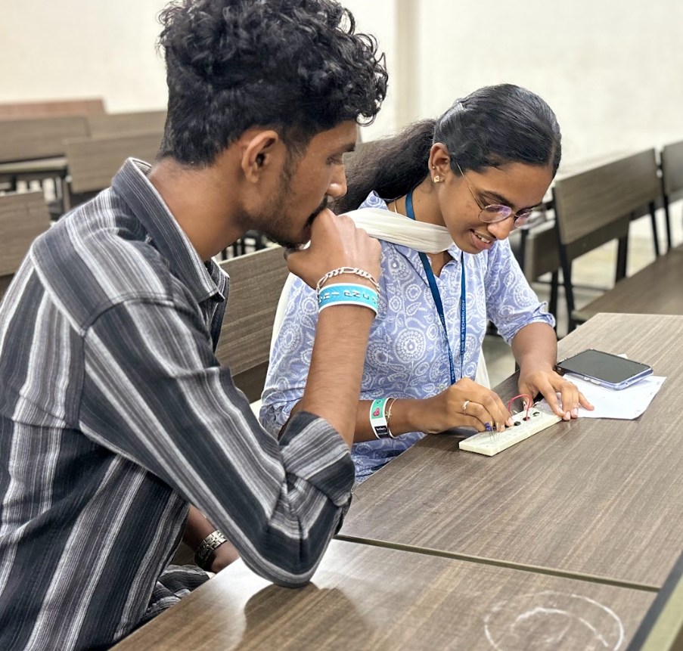

CIPHERHUNT
The Non-technical event CIPHERHUNT was one of the most prominent highlights of DECIBELS 2025. It was meticulously designed to test students’ analytical thinking, teamwork, and problem-solving skills through creative and intellectually stimulating challenges. This year, CIPHERHUNT comprised two engaging rounds that kept participants fully immersed from start to finish
- SHERLOCK SHOWDOWN
- FLIP FRENZY
ROUND-1: SHERLOCK SHOWDOWN
On 16 October, the first round titled “SHERLOCK SHOWDOWN” challenged participating teams of two to unleash their detective instincts by unraveling a sophisticated crime story. Each pair was presented with a crime scene and a case sheet filled with fragmented clues and crime-scene scenarios that required sharp analytical thinking and keen attention to detail. The task was simple in description but complex in execution: identify the culprit by connecting the interwoven clues scattered throughout the scene and the case sheet.
ROUND-2: FLIP FRENZY
The game “Flip Frenzy” combines luck, skill, and knowledge as teams compete to claim numbered boxes on a grid. It begins with a bottle-flip event: all teams attempt to flip a bottle simultaneously, and the first team to land it successfully earns the chance to proceed. That team then draws a chit, selecting a specific box on the grid. They must complete a coordination task or solve a riddle within the time limit; if successful, they capture the box for 10 points and mark it for their team. Once all chits are drawn and every box claimed, the team that owns the most boxes wins.
